Shift2Rail Joint Undertaking partners with International Rail Forum & Conference 2020

November 21, 2019

Category: [Latest News](https://shift2rail.org/news/), [Newsletter 11](https://shift2rail.org/newsletter-11/)

**The International Rail Forum & Conference (IRFC) is one of the leading events in the international railway calendar, bringing together top managers, railway and logistics experts, customers, prominent politicians and institutions from across Europe. The 7th IRFC will be held in Prague from 1 to 3 April 2020 at the Clarion Hotel Prague with the motto: “*Let’s build a new generation of railways together*”.**

[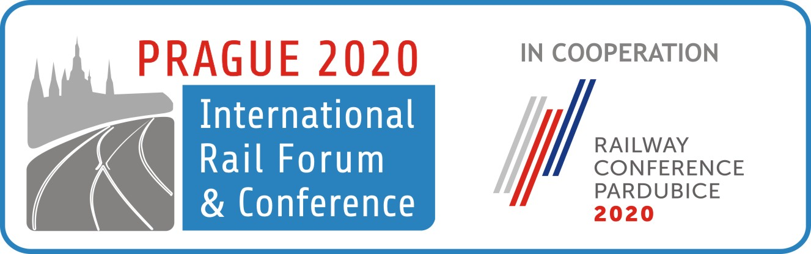](http://irfc.eu/en/registration/)

Shift2Rail is supporting the IRFC conference together with other international institutions and organizations, including ERA, UNIFE, CER, UIC and OSJD.

The main topics of the upcoming conference will be focused on the impending changes in the area of legislation, as well as research and technology, with focus on all railway areas – rail freight transport, infrastructure and passenger transport. IRFC 2020 will be kicked off by the conference organiser, OLTIS Group, Vice President of the European Parliament, Mrs Dita Charanzova, European institutions representatives, and representatives of the Czech Chamber of Deputies, as well as members of the Czech government.

For more information about the sessions please visit [IRFC2020 Sessions.](https://irfc.eu/en/about/topics/%20)

We look forward to the event and meeting the Euro-Asian rail freight world in the heart of Europe.